**Option Pricing Comparisons:**

The following script compares multiple approaches to pricing call and put options.

We will start by creating a class based structure for multiple option pricing models.

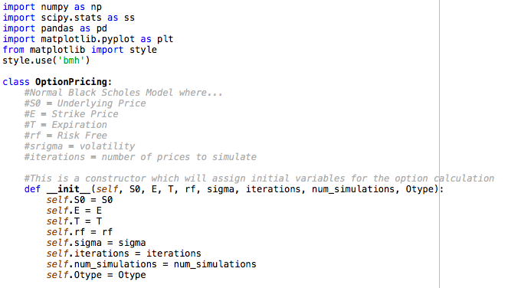

We will initialize a constructor to pass in the various parameters which we will need to price the options. Note the variable definitions are included in the code.

Next we will create a method to generate option prices with a loop:

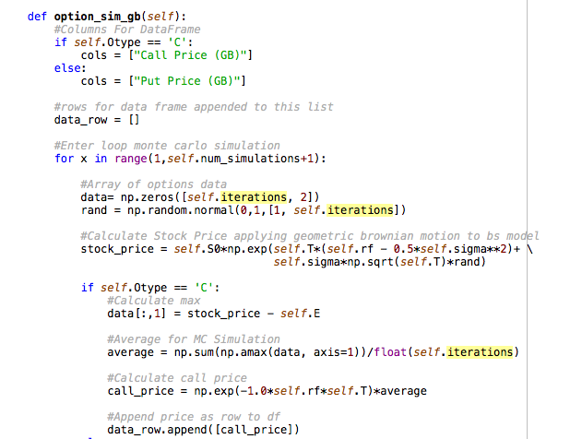

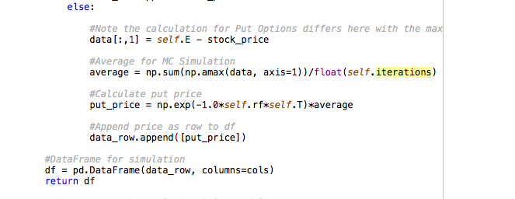

Next we can create a method for the classic Black Scholes model.

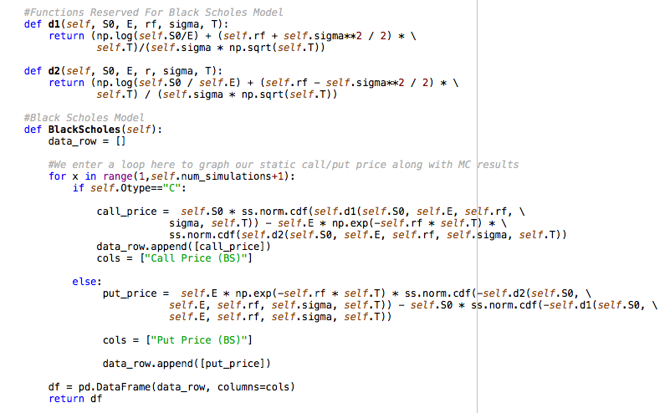

Next, we can create a method for the Antithetic model…

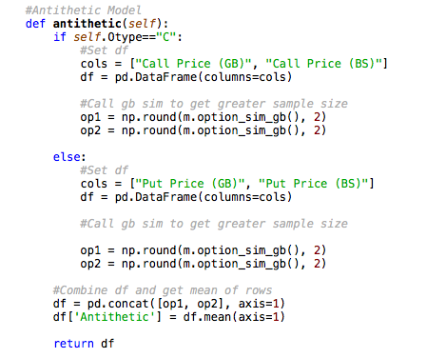

Finally, we can output our results with the following methods:

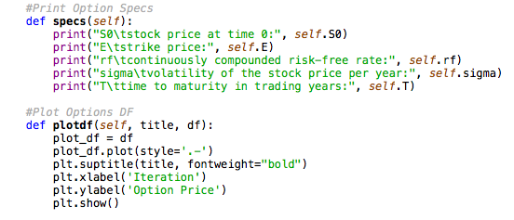

Results:

The following inputs were utilized:

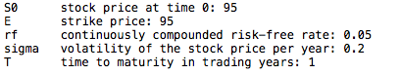

We can plot the GB simulation compared to the BS approach:



Next we can output the standard error between the two approaches:

Screen%20Shot%202018-06-12%20at%203.15.43%20PM.png

We can also compare the results in a data frame manipulating a few of the variables. For instance, the strike price and time to expiration are being modified here:

The Strike Price is represented by the index while the time to expiration is represented by the column header.

